# Assignment -1

Python Programming

|  |  |
| --- | --- |
| Assignment Date | 2 NOV 2022 |
| Student Name | B.Brundha,S.hemalatha,R.Kartheeswari,S.Sneha |
| Student Roll Number | 95191902015,95191902034,95191902043,  95191902307 |
| Maximum Marks | 2 Marks |

# Question-1:

Write a program which will find all such numbers which are divisible by 7 but are not a multiple of 5, between 2000 and 3200 (both included). The numbers obtained should be printed in a comma- separated sequence on a single line.

|  |
| --- |
| **Solution:** |
| a=[]  for i in range(2000, 3201):  if (i%7==0) and (i%5!=0):  a.append(str(i))  print (','.join(a)) |
|  |

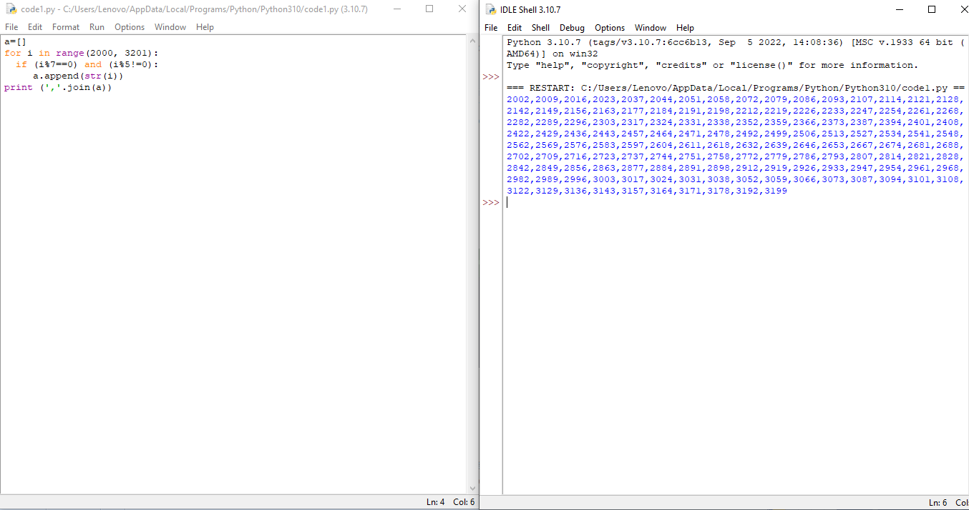

# Question-2:

With a given integral number n, write a program to generate a dictionary that contains (i, i*i) such that is an integral number between 1 and n (both included). and then the program should print the dictionary.

Suppose the following input is supplied to the program: 8

Then, the output should be:

{1: 1, 2: 4, 3: 9, 4: 16, 5: 25, 6: 36, 7: 49, 8: 64}

**Solution:**

k=int(input())

s=dict()

for i in range(1,k+1):

s[i]=i*i

print(s)

